JOB DESCRIPTION
Job Title | Head of Group Organization Support and Procedures Department | Location | Headquarters
Code | C2006 | Edition | 2
Division | Group Organization Development, Information Systems and Operational Support Division | Department / Unit | Group Organization Support and Procedures Department
Creation Date | February 2006 | Revision Date | March 2016
Employee Name |  | Employee Starting Date in Position

1- JOB PURPOSE
- Implementing and continuously improving the Group Bank’s processes and organization structure along with Committees roles and responsibilities in order to align the organization structure with the Bank’s vision statement and business strategy.

2- LINES OF REPORTING
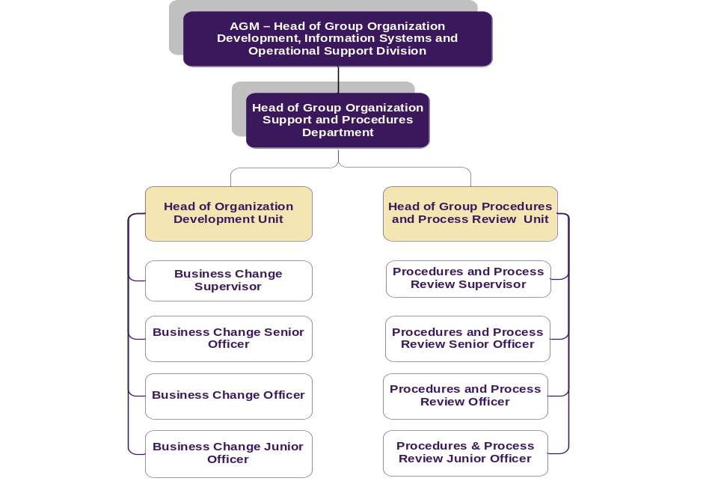

3- ORGANISATION RELATIONSHIP
- All Byblos Group entities, all the divisions, departments and units.

4- DUTIES & RESPONSIBILITIES
- Analyze, reengineer and implement changes on all the Byblos group processes (this includes simplification of processes, centralization, outsourcing, cost reduction and any other action leading to a best practice).
- Discuss and identify with all parties potential improvements in the Bank’s working methods and present, in coordination with all Divisions and Departments, related proposals for approval
- Build and propagate a dynamic and performance oriented organizational structure
- Discuss with all parties possible enhancements to the organization structure and propose new structure / changes to the Management for approval
- Own and supervise all the organizational projects affecting divisions, departments, units and branches in the Bank
- Define responsibilities and job descriptions for all Divisions / Departments / Units’ new or amended functions in coordination with the Human Resources Division
- Implement any change in the organization structure and supporting management systems
- Supervise the preparation of all the charters of the Bank’s Committees for the group and follow-up the implementation
- Supervise the Organization Development unit responsible for the Organizational projects in the Group.
- Supervise the procedures and process review unit responsible for the preparation and the review of the group procedures
- Manage the OSP master plan by adding, allocating and following-up all the projects and tasks that need to be prepared by OSP

5- JOB REQUIREMENTS
- Education Level:
- MA in Business Administration, or other related fields
- Strong background in banking

- Experience :
- Banking experience of more than 7 years especially in banking operations

- Required Competencies:

Technical
- Ability to effectively direct & integrate all aspects of a project, ensuring that work progresses toward achieving
- Banking Experience (Banking Knowledge)
Behavioural
- Ability to originate new practices, concepts & ideas (Creativity & Innovation)
- Ability to originate new practices, concepts & ideas (Creativity & Innovation)
Managerial
- Ability to allocate decisions and responsibilities in order to maximize the Bank's and individuals effectiveness (Delegating Responsibility)
Personal Characteristics
- Ability to monitor repeatable business processes and create new ones according to the Business needs (Process Management)

6- WORKING CONDITIONS
- Environmental Conditions: The jobholder will work in a relatively high pressure environment that requires adherence to various deadlines; the ability to withstand stress and motivate staff is vital.
- Physical Conditions: The job is largely desk based; accordingly, it does not require any significant physical effort and does not expose its job holder to any significant environmental threats.

7- MATERIALS USED
Tools used in this occupation:
- Computer
- Telephone

Technology used in this occupation:
- Office suite software
  - Presentation software (e.g. Microsoft PowerPoint)
  - Spreadsheet software (e.g. Microsoft Excel)
  - Word processing software (e.g. Microsoft Word)
  - Visio for flowcharts
  - Flow on
- Electronic Mail Software (e.g. Microsoft Outlook)
- Internet

I affirm having received, read and understood my Job Description.

Employee Name / Signature

Date

Direct Supervisor Name / Signature

Date

